For more information on this property, contact the Arapahoe City Office at (308)962-7445.
512 Nebraska Avenue, Arapahoe, NE 68922
Price:
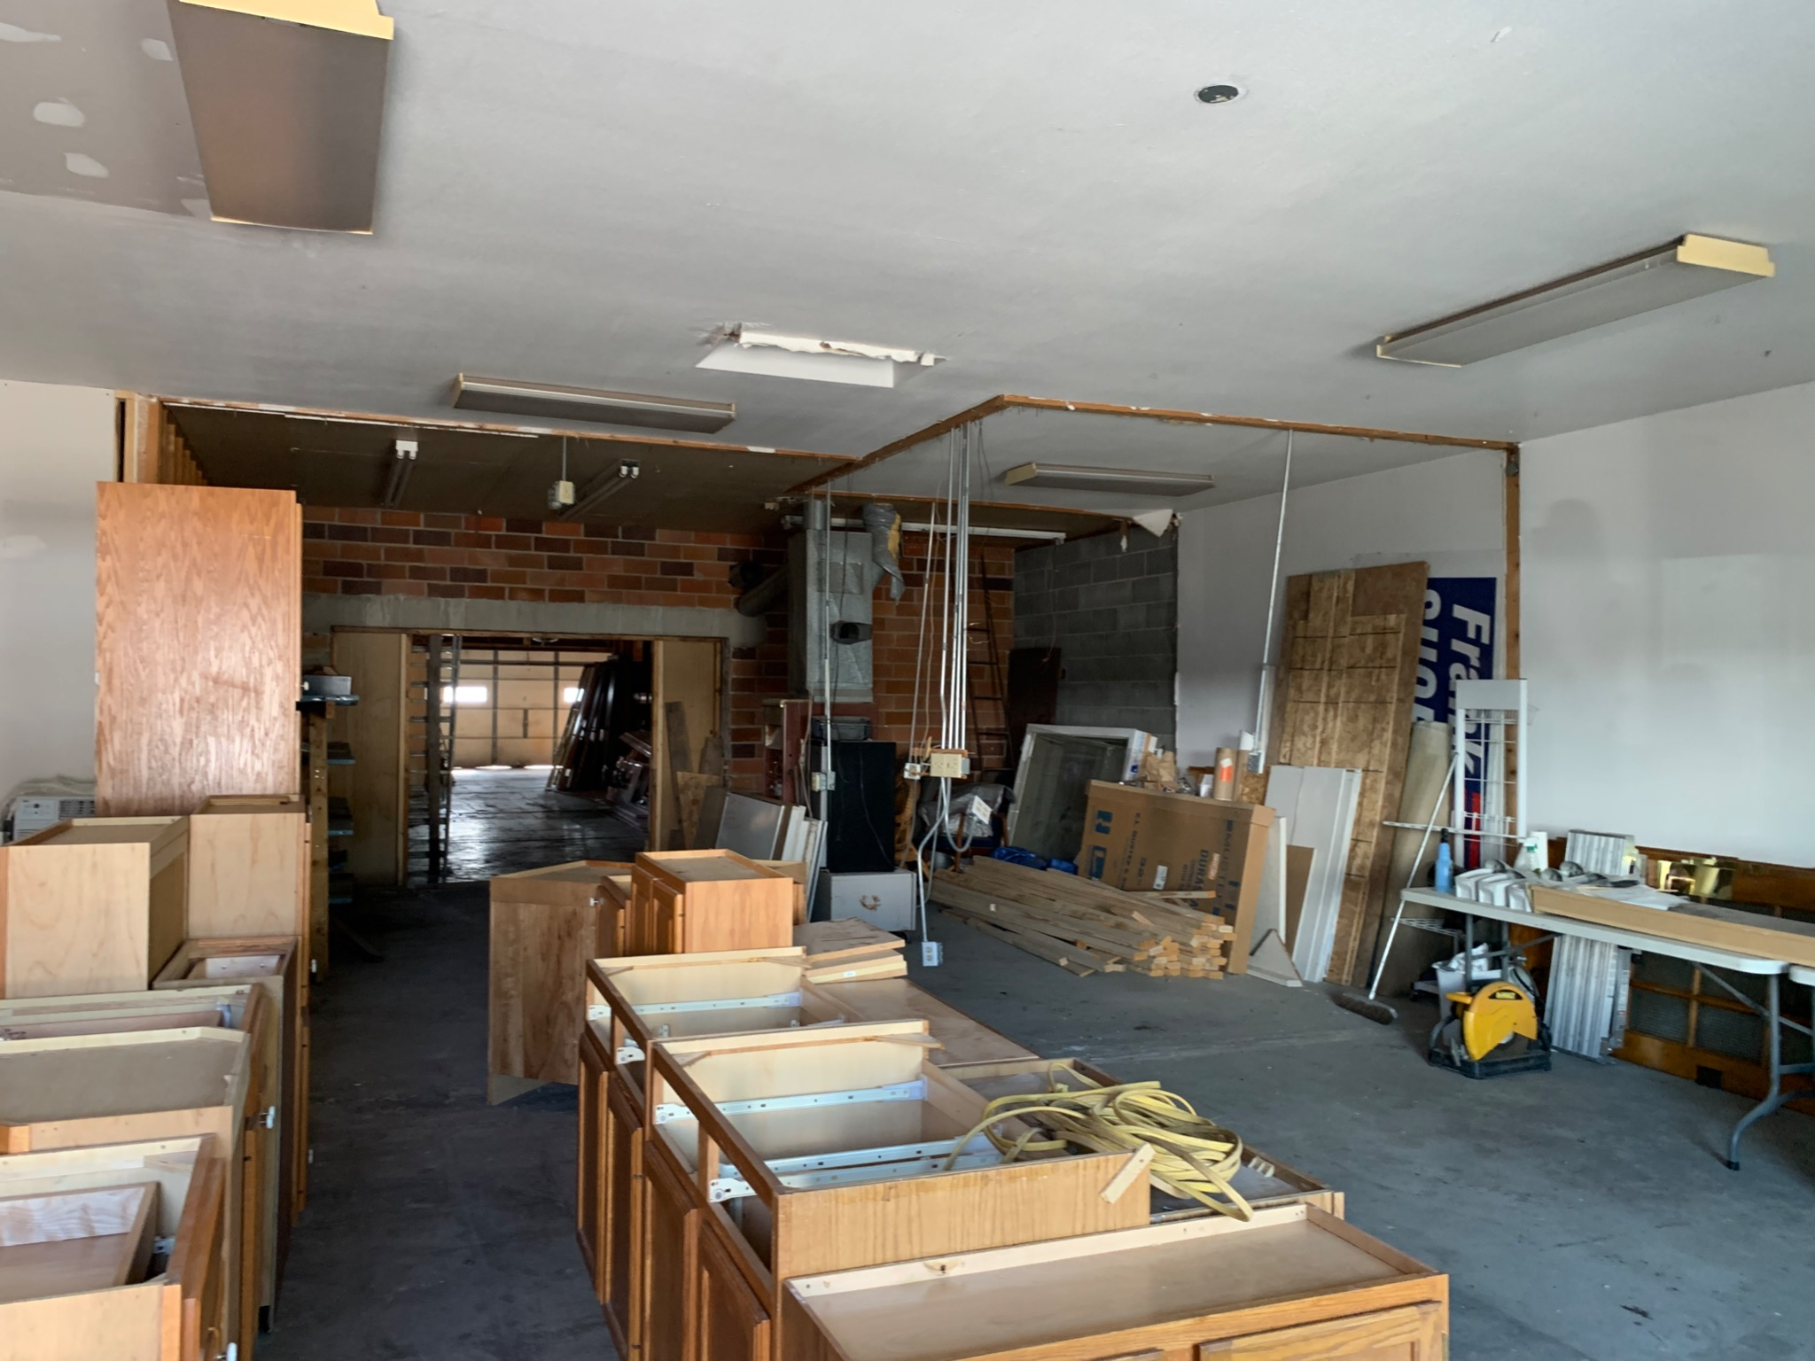
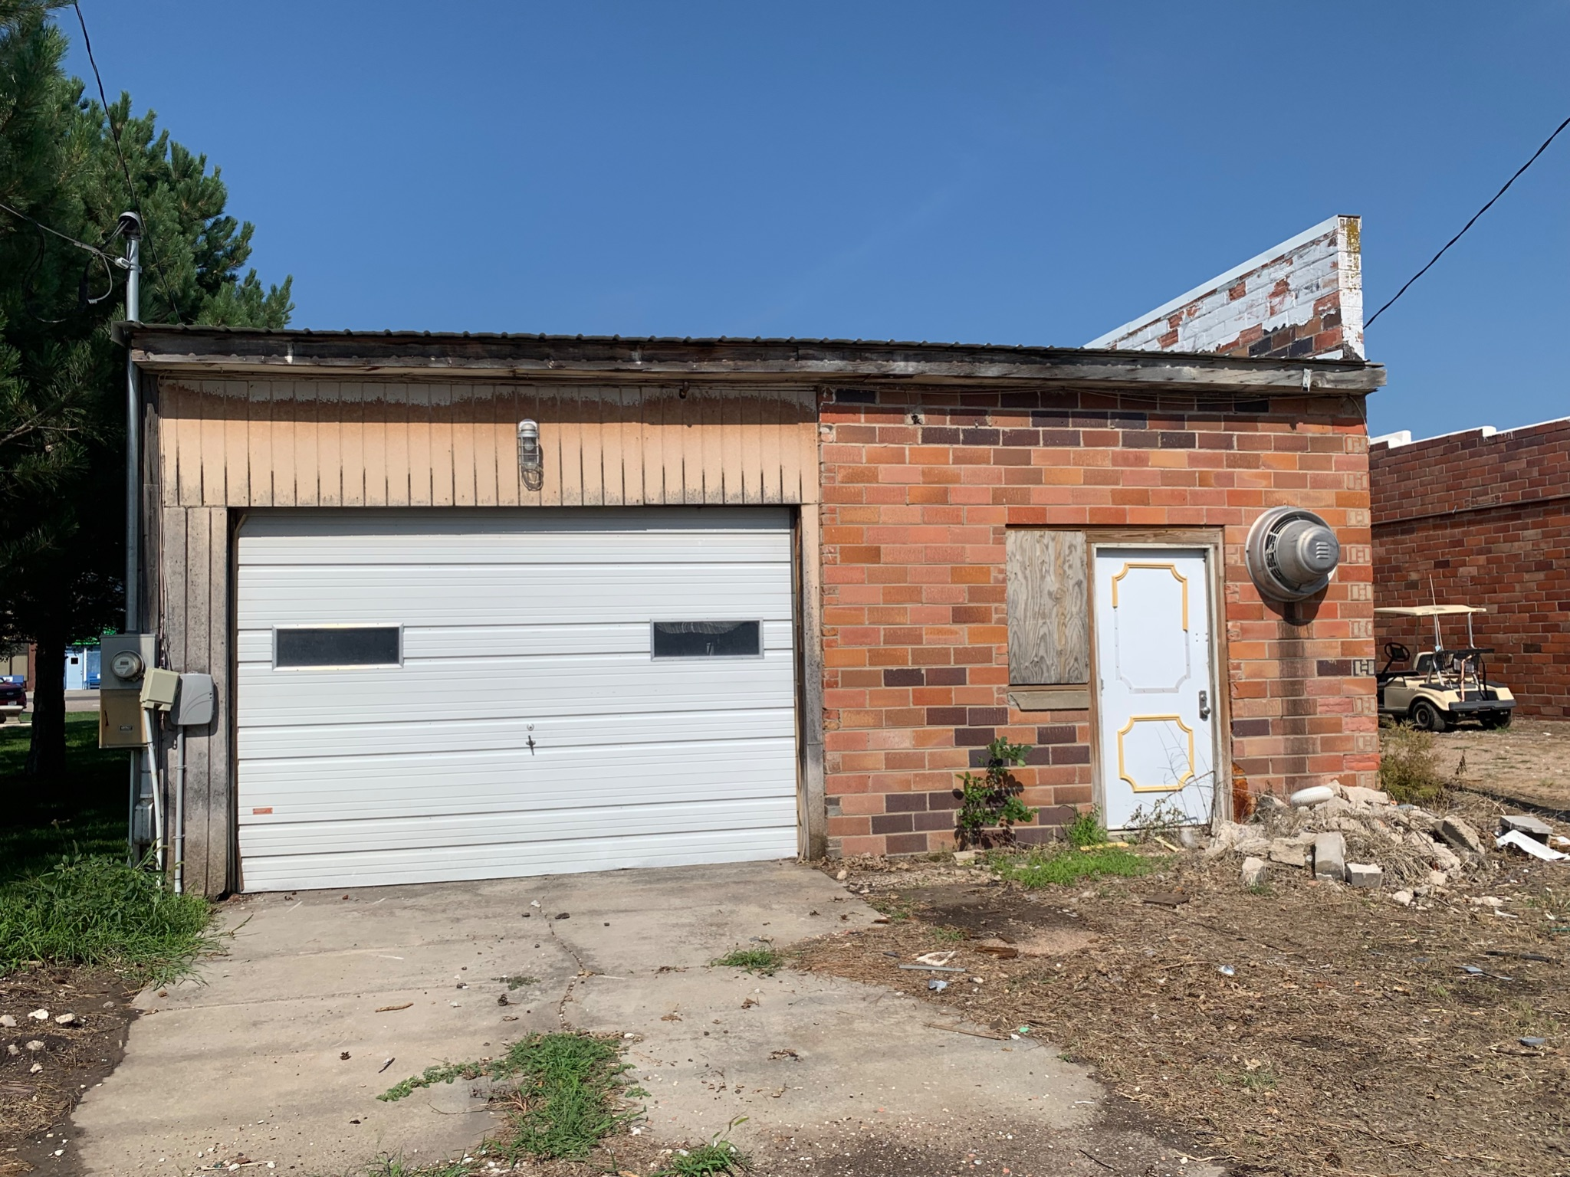
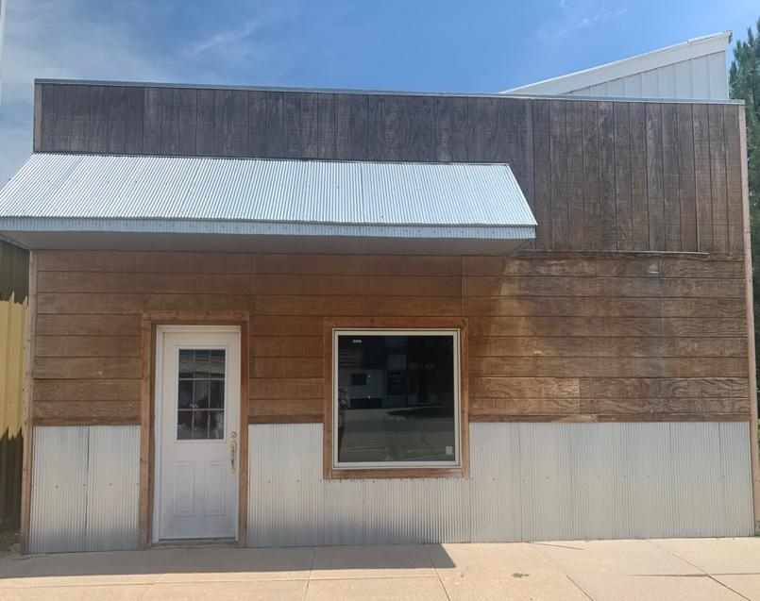
Status: Inquire

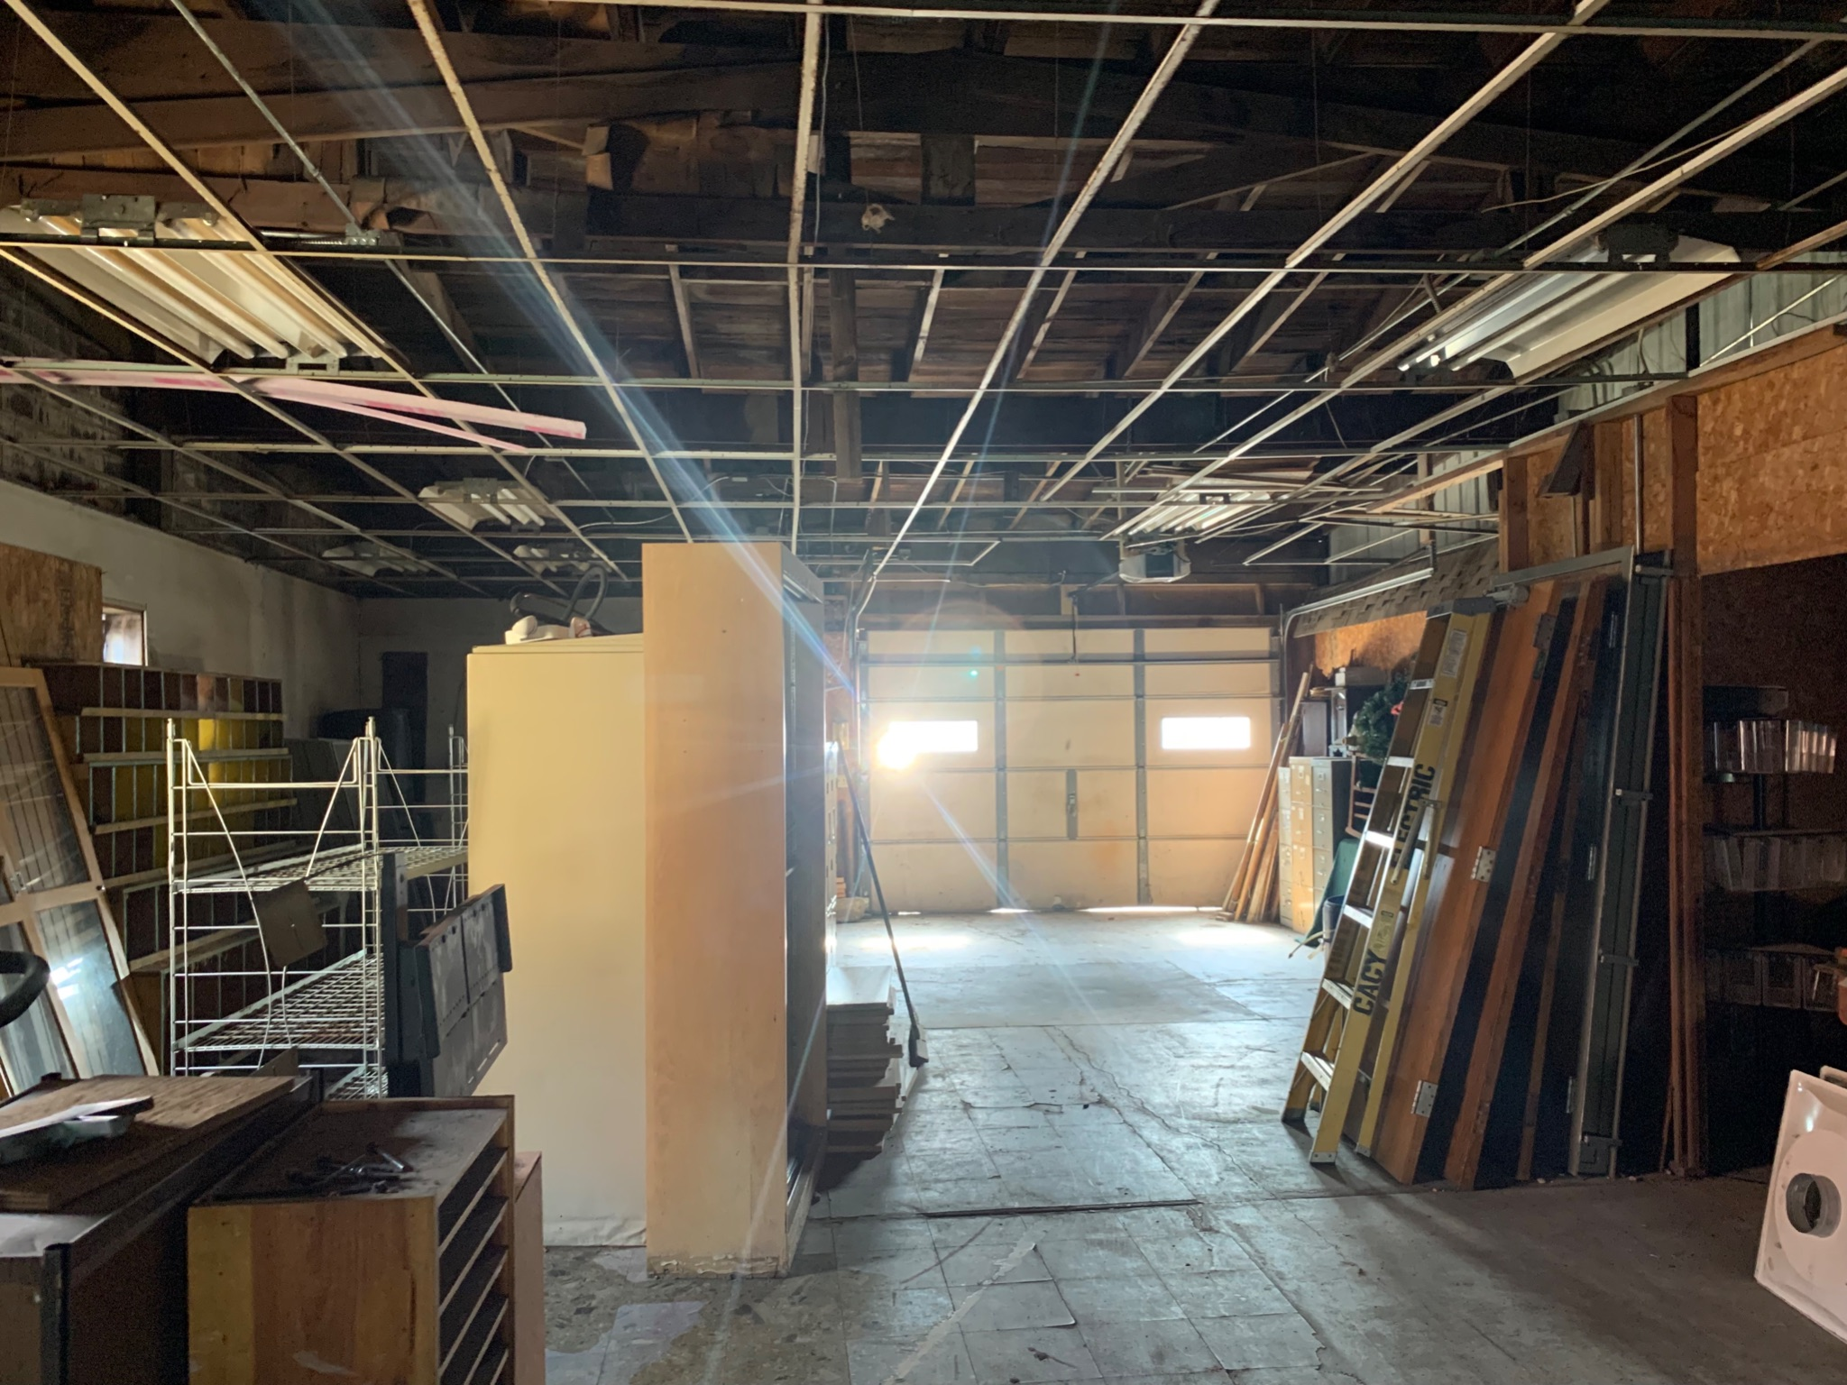
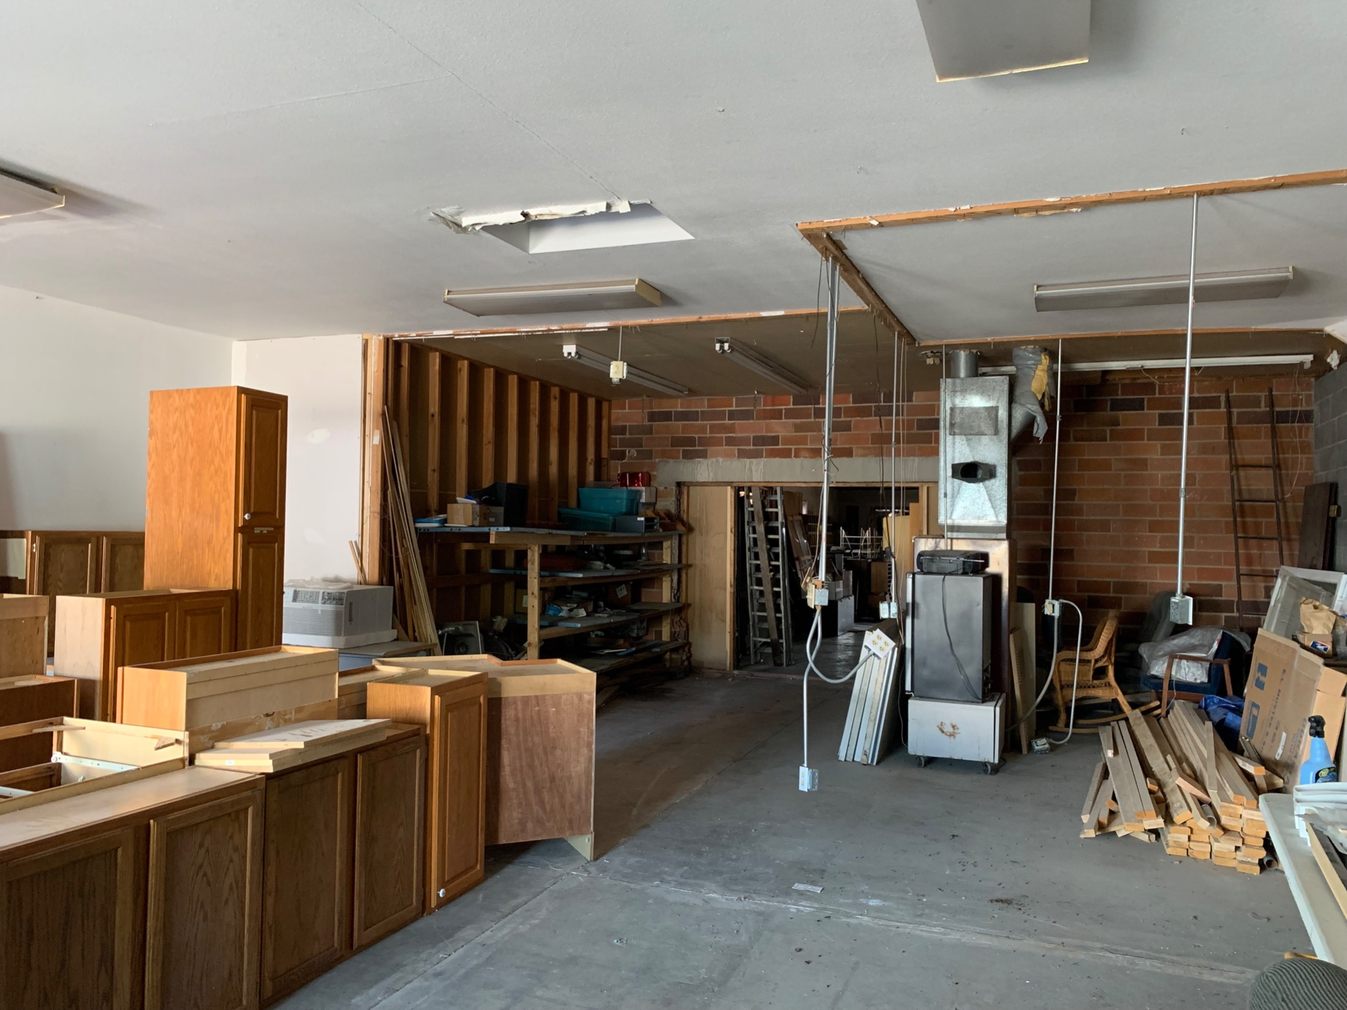

Property Description:
Are you interested in bringing a business to Downtown Arapahoe? This recent outdoor remodel located on Highway 283 in Downtown Arapahoe would be perfect for your next business endeavor! Parking space located in front and back of business. One unfinished bathroom on property but includes possible space for second bathroom installation. Along with a recently replaced metal roof, the property is sided with both wood and metal as well. Large garage door on back of building with plenty of space inside for parking and storage!
Primary Features:
County: Furnas
IDX City Name: Arapahoe
IDX County Name: Furnas
Off Market Date: N/A
Photo Count: 5
Property Sub Type: COMMERCIAL
Property Type: Commercial
Sold Date: N/A
Additional:
Approximate Age: 61+ years
Construction: Concrete block
Miscellaneous:
Present Use: Storage
Stories: 1
Utilities: City sewer, city water
Interior Features:
Approximate SqFt: Main: 2,688
Approximate SqFt: Upper: N/A
Building SqFt: 2,688
Ceiling Height: 14ft
Cooling:
Floors: concrete slab
Freight Elevator: N/A
Heat Type:
Office SqFt:
Retail SqFt: 780
Total SqFt: 2,688
Warehouse SqFt: 1,908
External Features:
Area: Arapahoe
Foundation:
Lot Size: Approx 27 x 100
Number of Units: 1
Overh Door Width: 12wX8h
Overhead Doors: 1
Overhead Driveway Height:
Parking: Street Parking, 1 Garage door on back of business
Parking Capacity: 10-15
Roof: Metal, recently completed
Siding: Wood, concrete, metal
Financial Details:
Auction: No
Best Potential:
Flood Insurance:
Possession:
Sale/Rent: Yes
Tax Year:
Taxes: $190.00
Terms: Negotiable
Utilities Average Per Year:
Utility Paid by Owner: Cable, electric, garbage, gas, water
Utility Paid by Renter:
Location Information: Arapahoe, NE
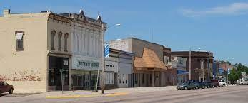
Arapahoe, Nebraska, located in Furnas County, in southwest Nebraska, is a busy, rural community of 1,028. Founded in 1871 and home to the Our Lady of Fatima Shrine, a Veteran's Memorial, numerous parks and ballfields, city pool, municipal golf course, volunteer operated movie theater, and more, we welcome you to Arapahoe and invite you to bring entrepreneurial ventures to buildings like this one!

Education: Arapahoe-Holbrook Public Schools
- Recently renovated in 2018, Arapahoe-Holbrook school provides education and additional opportunities for pre-school to high school students. Our student warriors actively compete in a number of activities including a variety of sports, FFA, FCCLA, quiz bowl, etc.
Healthcare:
- Arapahoe Dental Clinic
- Arapahoe Medical Clinic (Tri-Valley Health System)
- Arapahoe Pharmacy
- Arapahoe Physical Therapy
- Arapahoe Vision Clinic
- Cappel Chiropractic and Personal Training
- Milligan Chiropractic
- Tri-Valley Physical Therapy
Community Life: Recreation:
- First United Methodist Church
- River Valley Evangelical Free Church
- Christian Church of Christ
- St. Paul’s Episcopal Church
- Trinity Lutheran Church
- St. Germanus Catholic Church
- Arapahoe Food Pantry
- Good Samaritan Society
- Arapahoe Public Library
- Crystal Theater
- Arapahoe Ball Parks
- Arapahoe City Park
- Arapahoe Municipal Golf Course
- Arapahoe Municipal South Park
- Arapahoe Plunge and Splash Pad
- Arapahoe Tennis Courts
- Tornado Alley

